**EC2 Instance Launching and Configuring**

**Step1**: Select the EC2 instance from the Services.

**Step2**:Click on launch instance.

Name the EC2 Instance

Select the AMI (It is Amazon Linux by Default)

The Instance type is t3.micro

Create a new key pair and download the key pair and click on launch instance.

**Step3**: Now to create a key pair, click on create a new key pair and name the keypair. The keypair type must be RSA and the private key file format must be .ppk for use with PuTTY.

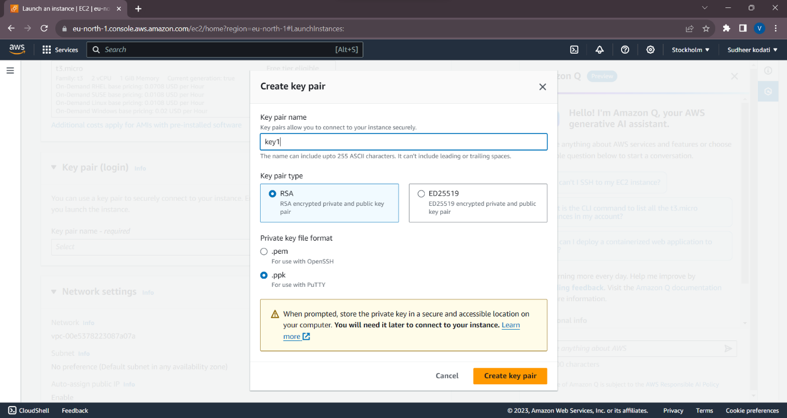

**Step4:** Now click on launch instance.

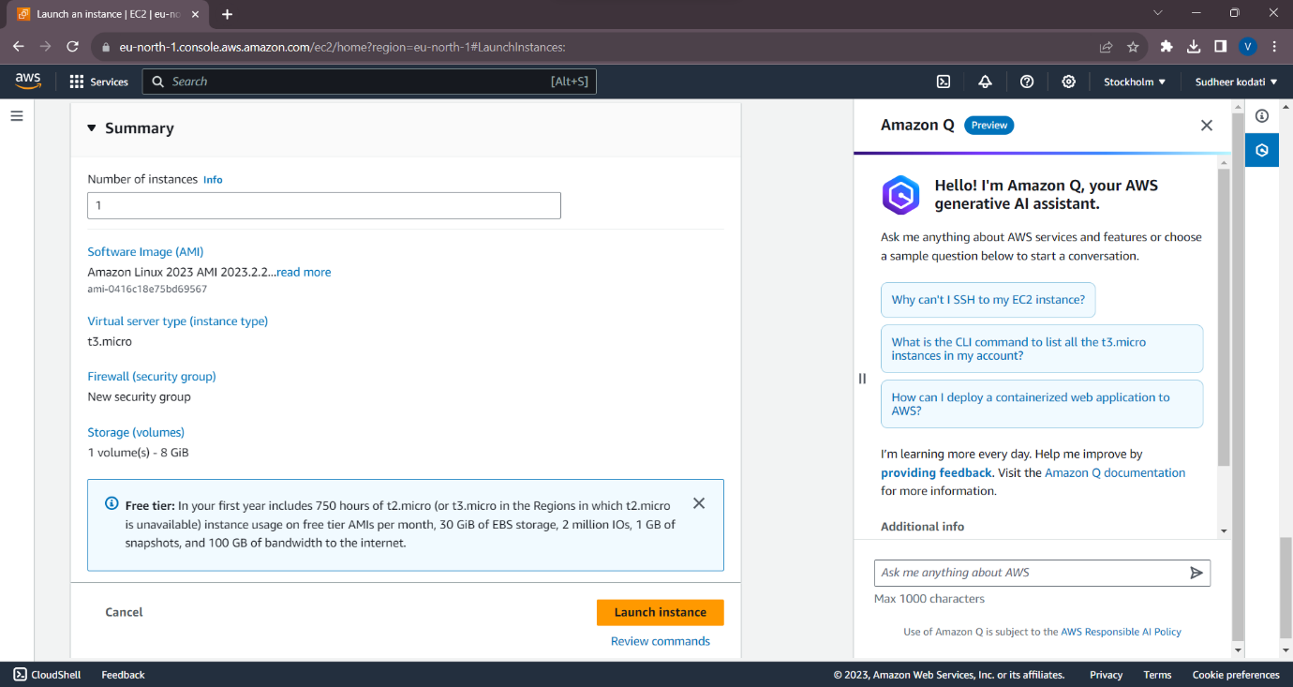

**Step5:**Click on view instances and you will see that the instance is in a running state.

By selecting instance click on the connect option then we will see the following information copy the address as shown in image.

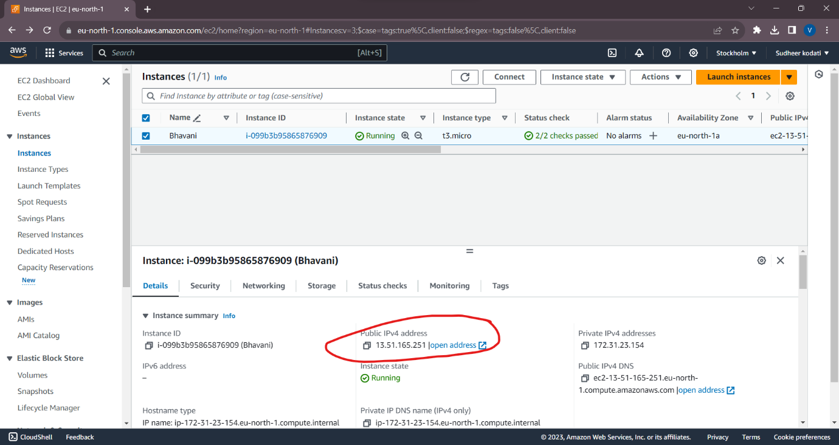

**Step6:** Connect to the Linux instance from the Windows client operating system using Putty:

Follow the below steps to connect to the Linux instance from the Windows client operating system using putty:

**Step7:** Install and open puttygen application and click on the load.

Browse and select the keypair file i.e. .pem file and click on the save private key and a .ppk file will be saved.

**Step8:** Open putty application and paste the host address copied from the connect to instance tab, which we have previously copied.

**Step9:** Now click on SSH and click on auth tab and browse for the .ppk file which we have saved earlier and then click on open.

**Step10:** You will be prompted to click on accept, click accept.

**Step11:** Now the putty terminal will be open where we can access the EC2 install that is running on AWS servers.